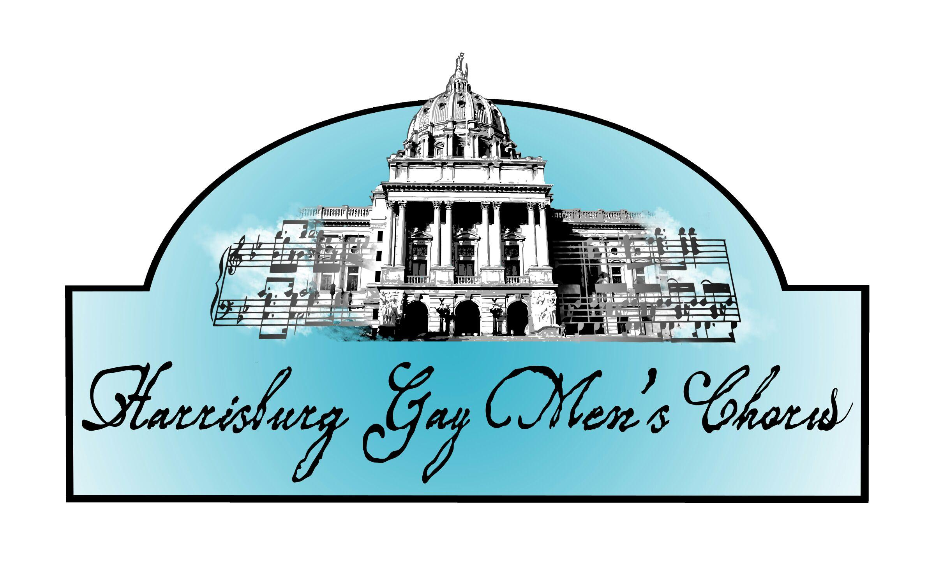

Vision Statement

The Harrisburg Men’s Chorus aspires to create entertaining, fun, and vibrant gay-positive musical programs, while creating an understanding and welcoming community for commitment and positive growth.

Mission Statement

The Harrisburg Men’s Chorus celebrates the GLBT experience in song and performance, fosters a greater appreciation of the male choral musical tradition, nurtures members in their artistic and personal growth, and enriches the region through entertainment and positive interaction.

