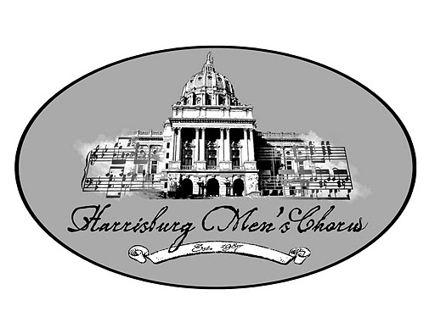
25th Anniversary Season
2011 – 12 Calendar
September 12th , 7:00 – 9:30 pm 1st regular rehearsal of the season, Unitarian Church of Hbg
September 25th, 3:00 Pampered Chef Fundraiser, Bar 704
October 3rd, 6:30 – 9:30 pm Sectionals/small ensemble rehearsal start before regular rehearsals
October 4th Boscov Volunteer Days, Fundraising event
October 10th, Time TBA Retro Tea Dance Fundraiser, Details TBA
November 6th , Time TBA ‘Pay the Rent’ Sunday service
December 1st, 6:30 – 9:30 pm Final rehearsal, Christmas Cabaret
Decenber 2nd, 7:00 pm Performance, Christmas Cabaret, 1st Reformed Church, Lancaster (Tentative)
December 4th, 2:30 – 9:30 pm Performance, Chours Christmas Capers Cubed, 4 and 7 pm, Hbg Maennerchor
January 7th – 14th Farm Show
February 15th, 6:30 – 9:30 pm Final rehearsal, Colors of Our Lives
February 17th, Time TBA Performance, Color of Our Lives, either at Dickinson College or 1st Reformed
February 18th, 6:30 – 10:00 pm Performance, Color of Our Lives, Unitarian Church of Harrisburg
February 19th, 6:30 – 10:00 pm Performance, Color of Our Lives, Unity Church
Febrauary 26th, Time TBA Oscar Party, Chorus fundraiser
February 27th, 7:00 – 9:30 pm 1st rehearsal for “Family Jewels”, Unitarian Church of Hbg
March 26th, 6:30 – 9:30 pm Sectionals/small ensemble rehearsal start before regular rehearsals
April 15th, Time TBA ‘Pay the Rent’ Sunday service
April 20th, 5:00 – 9:30 pm Lavender Graduation, Penn State Main Campus
May 18th, 7:00- 9:30 pm Performance, Family Jewels, 1st Reformed Church, Lancaster (Tentative)
June 6th, 6:30 – 9:30 pm Final rehearsal, Family Jewels, Krevesky Production Center
June 8th, 6:30 – 10:30 pm Performance, Family Jewels, Krevsky Production Center
June 9th, 7:00 – 10:30 pm Performance, Family Jewels, Krevsky Production Center
June 10th, 1:00 – 5:00 pm Performance, Family Jewels, Krevsky Production Center, Strike after
June 10th, Time TBA Tony Party, Chorus Fundraiser
June 18th, 7:00 - 9:00 pm Rehearsal: Voices United and GALA
June 25th, 7:00 – 9:00pm Rehearsal: Voices united and GALA
July 7th – 11th GALA in Denver, CO.
July 16th, 7:00 – 9:00 pm Rehearsal: Voices United
July 23rd, 7:00 – 9:00 pm Rehearsal: Voices United
July 26th, 6:30 – 9:30 pm Final Rehearsal, Voices United, Market Square Church
July 27th, 6:30 – 10:00 pm Performance, Voices United, Market Square Church
July 28th, Noon – 5:00 pm Pride Festival

