Resolution 2011-02: Establishment of HMC Logo

Whereas it is the responsibility of the Harrisburg Men’s Chorus (HMC) Board of Directors to approve all changes to the public image for HMC; and,

Recognizing that approval of the HMC logo is our most prominent public image; and,

Further recognizing that the logo should reflect the organization appropriately with regard to our Purposes as stated in our Bylaws; and,

Acknowledging that the community associates HMC with its logo; and,

Further acknowledging that the logo represents the branding of the organization;

Be it resolved, that all media beginning with the 2011-2012 25th Anniversary Season have a version of the logo shown here:
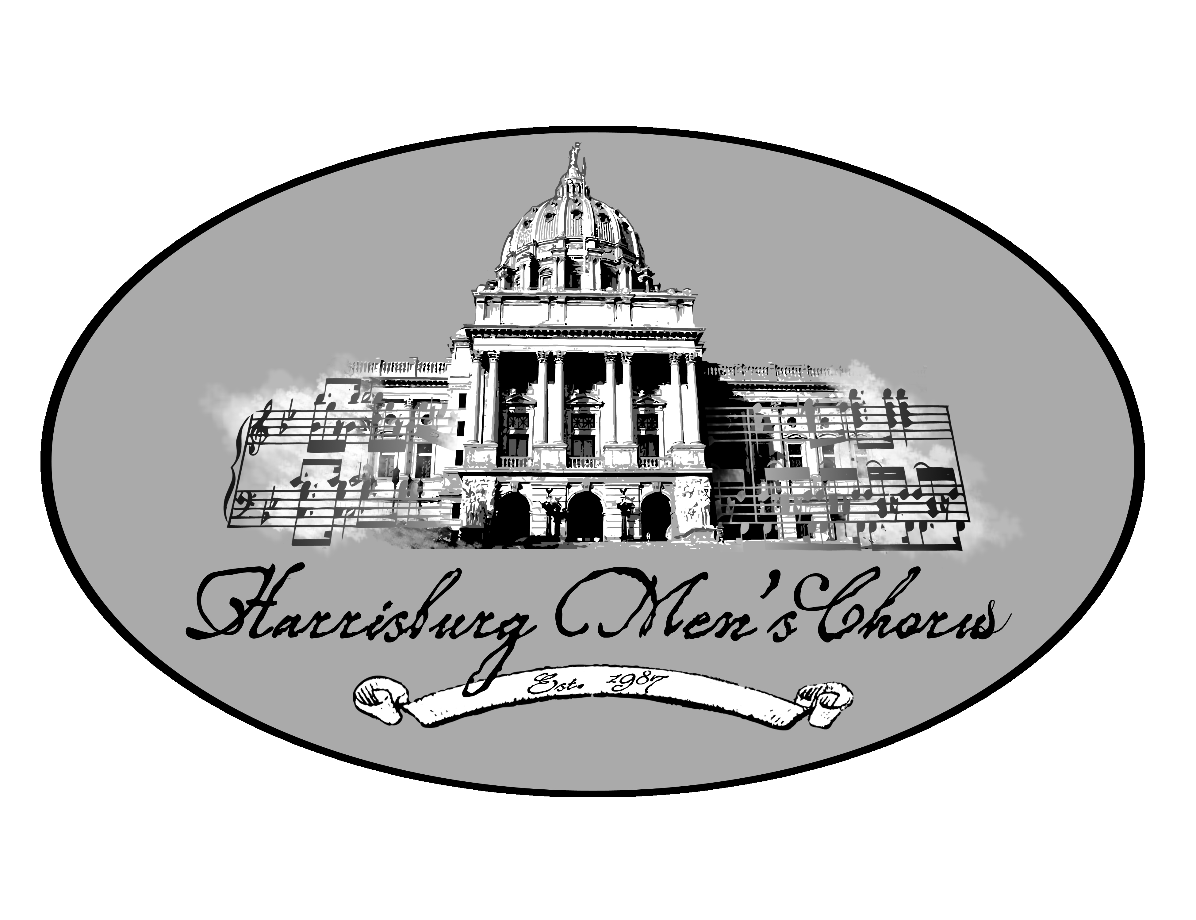

And, be it further resolved that this same logo will be similarly used to create standard letterhead for all HMC official correspondence.

Resolved, Sunday, May 15, 2011, by the Harrisburg Men’s Chorus Board of Directors.

